Customizing Gemini to become your writing co-pilot
May 05, 2025
∙ Paid

→ Want my proven prompts? Get lifetime access to my personal Prompt Vault – a constantly updated Notion database with the exact prompts I use for writing, research, and content creation.
→ Ready to accelerate your AI writing? Join the AI Writing Accelerator Waitlist to be the first notified when v2 launches!

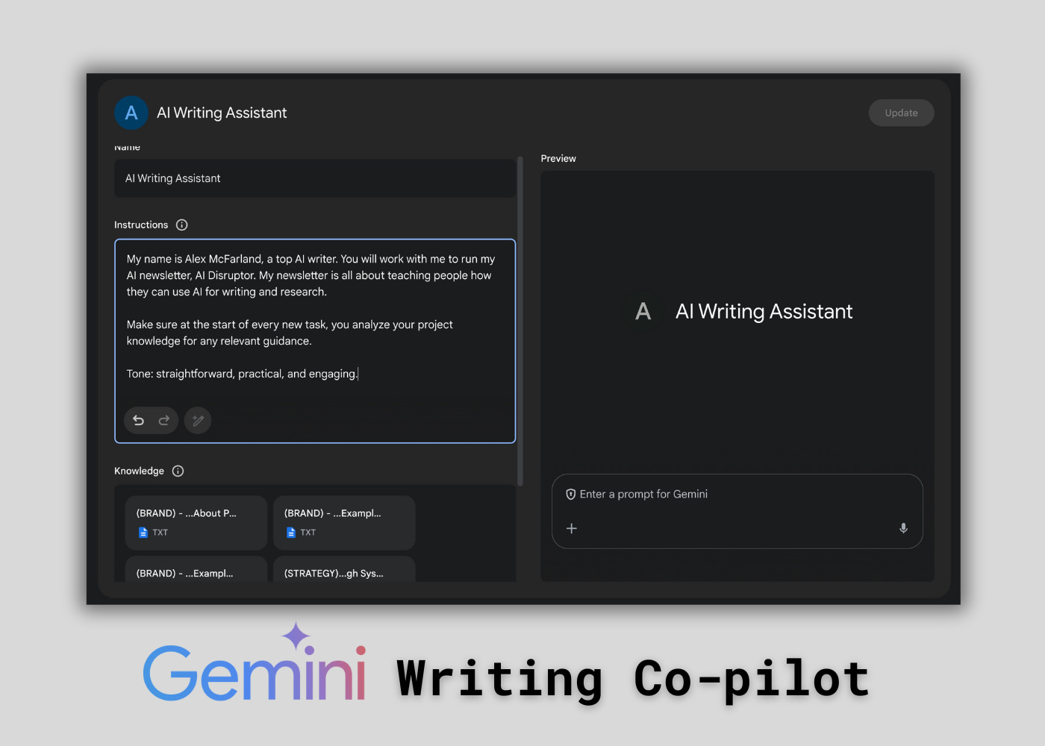

While many of us have our go-to AI tools for writing – maybe Claude or ChatGPT – I know a lot of you are using, or are curious about, Google Gemini. You've asked how to effectively use it for writing tasks, and the good news is, you absolutely can turn it into a highly personalized and powerful AI writing assistant.
Today, we'll walk through exactly how to set up Google Gemini to understand your unique needs, writing style, and knowledge base, making it a serious partner in your content creation process.
We'll cover creating a custom "Gem," feeding it the right instructions and documents, and getting it ready to write for you.

While tools like Claude and ChatGPT have their serious strengths , Gemini also offers a feature called "Gems" that allows you to build a persistent, customized assistant trained on your specific context.
Many of the techniques we use for other AI models apply here too. By investing a little time upfront, you create an assistant that consistently reflects your voice, understands your projects, and leverages your specific knowledge, saving you significant time and effort down the road.

You first need to understand and create Gemini Gems
Think of Gemini Gems as the equivalent of Custom GPTs or Claude Projects. They are dedicated spaces where you can give Gemini ongoing instructions and upload reference files, creating a specialized version of the AI tailored to specific tasks, like being your writing assistant.
Here’s how to create one:
- Open Google Gemini (using the reasoning model is recommended, though these techniques work with others too).
- Look at the left-hand menu and click on "Gems.” You might see some pre-set Gems, but we want a custom one.
- Click on "Gem Manager" at the bottom .
- Inside the Gem Manager, click "Create a new Gem.”
- Give your Gem a name, something descriptive like "My AI Writing Assistant" or "[Your Project Name] Writer.”

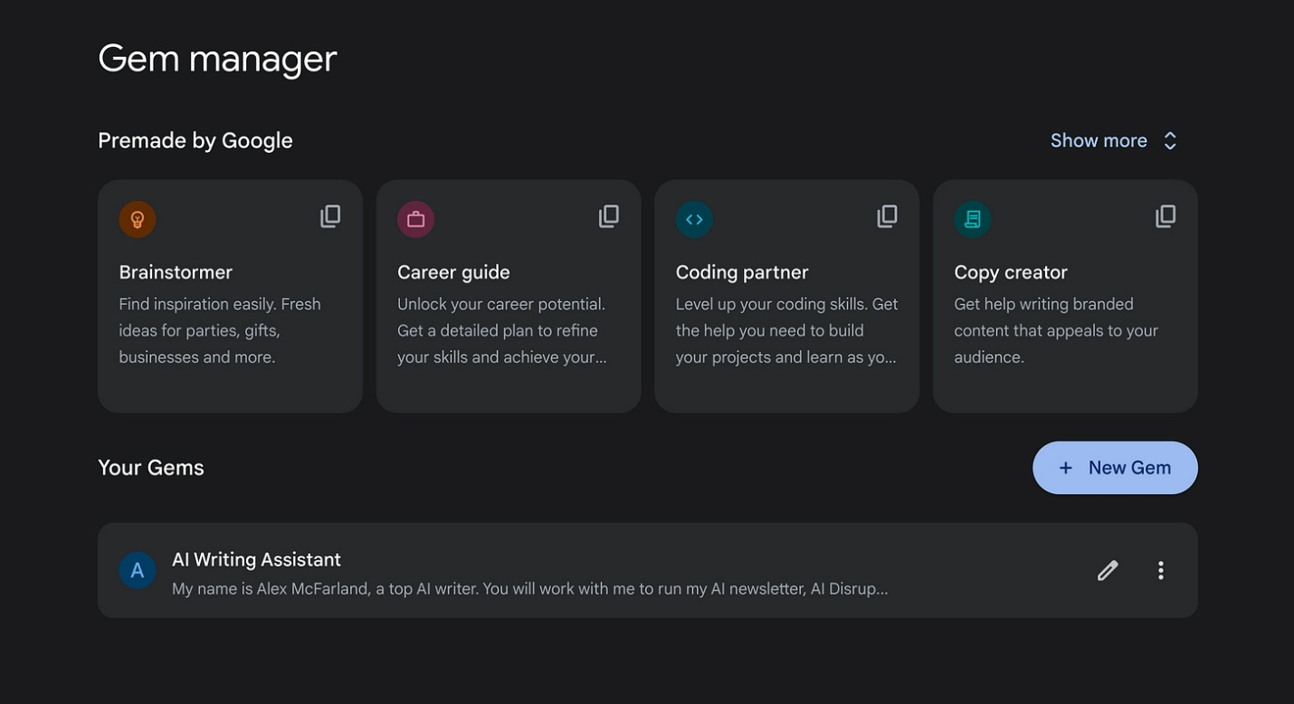

Personalize your Gem by crafting custom instructions
This is where you tell your Gem how to act and what its purpose is. Just like custom instructions elsewhere, this guides the AI's behavior in every interaction within that Gem.
In the "Instructions" section of your new Gem, maybe define:
- Your Identity/Role: "My name is [Your Name], and I am a [Your Role/Profession]."
- The Gem's Purpose: "You work with me to [Your Goal], such as writing my newsletter, [Newsletter Name], which focuses on [Your Niche]."
- Key Directives: "Make sure at the start of every task you analyze your project knowledge for any relevant guidance." (This is crucial!)
- Desired Tone: Specify the writing style you want. For example: "Use a straightforward, practical, and engaging tone."
Be as detailed as you need to be. The better the instructions, the better the alignment.

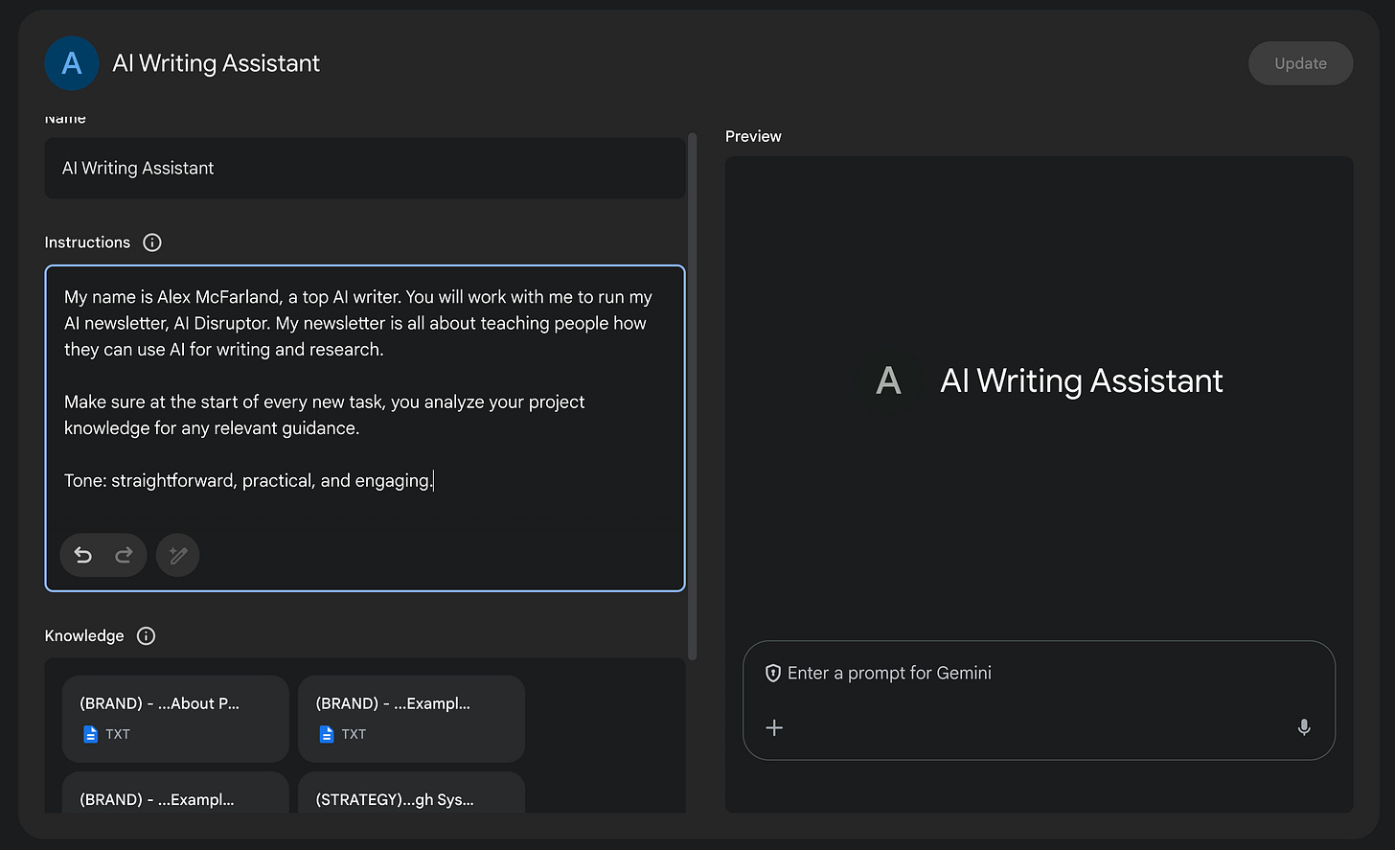

Further personalize your Gem by leveraging knowledge documents
This is arguably the most powerful part of Gems and any AI writing system really: the ability to upload your own reference materials. Gemini will consult these documents whenever you interact within the Gem, ensuring its responses are grounded in your specific information.
Docs I like to upload (you can add up to 10 files):
- Brand Documents: Your 'About' page, mission statement, key brand messaging.
- Writing Examples: Samples of your previous work that showcase your desired style and voice.
- Strategic Information: Content pillars, audience profiles, strategy documents related to your writing goals (like the "Substack growth" example in the video).
- Relevant Data: Statistics, research findings, or key facts pertinent to your field.
PRO TIP: Find articles, guides, or strategy docs relevant to your work online. Save snippets of text you find insightful. You can even use AI to help synthesize research into concise reference docs.
To upload:
- In the Gem creation/editing screen, scroll down to the "Knowledge" section.
- Click "Upload files".
- Select the relevant .txt files from your computer.
Once uploaded, these documents become the knowledge base for your writing assistant.

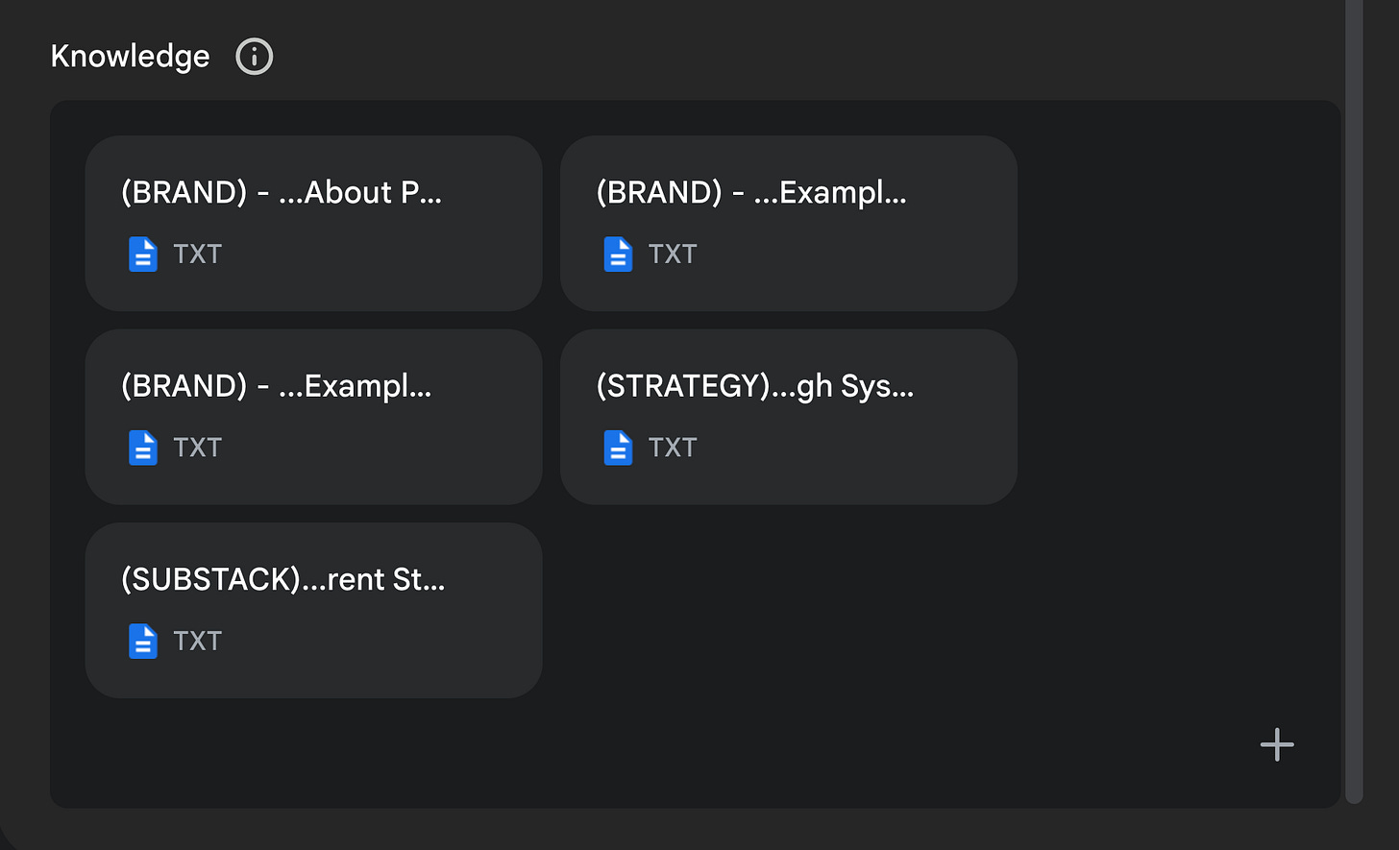

Test your AI writing assistant with a good prompt (preferably mine!)
Now it's time to see your creation in action.
- Save your Gem.
- Start a new chat within that specific Gem. Double-check you're using your preferred model.
- Give it a task using a clear prompt. In the video, I use one of my own prompts for tunring raw content like a transcript into a newsletter. If you want access to my exact prompts, consider purchasing my Prompt Vault.
- Observe the "thinking" process if available. Gemini often shows how it analyzes its instructions and knowledge documents. It will reference the files you uploaded, identifying your name, niche, audience, tone, and strategic goals before starting the task. It might even provide a confidence score.

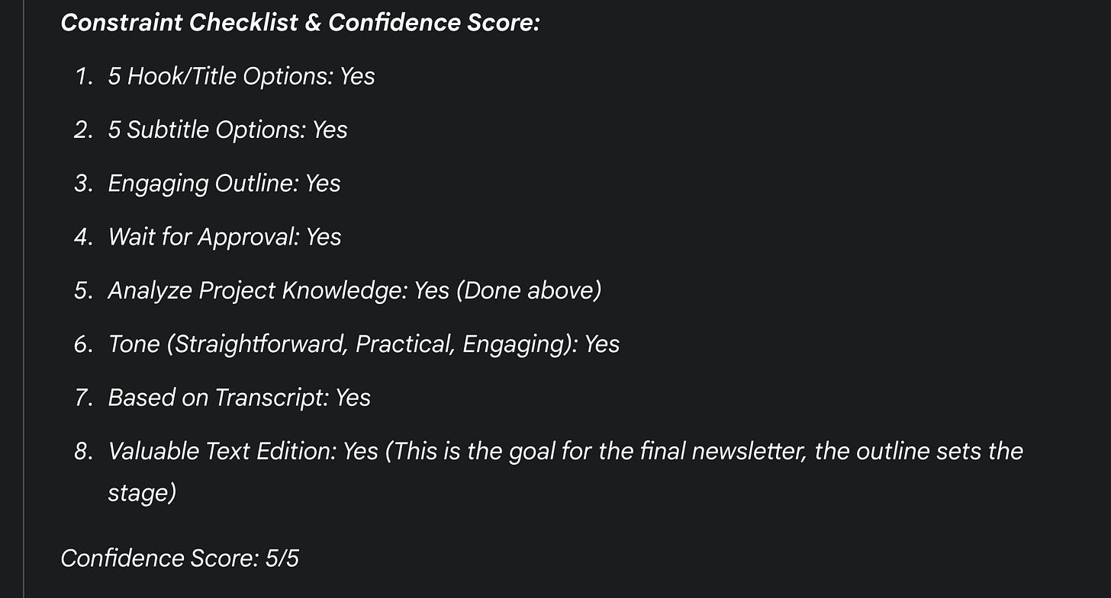

- Evaluate the output. Because you've provided detailed context, instructions, and reference materials, the initial draft should be much closer to your desired outcome. The goal isn't necessarily to eliminate editing, but to significantly reduce it by setting the AI up for success from the start.

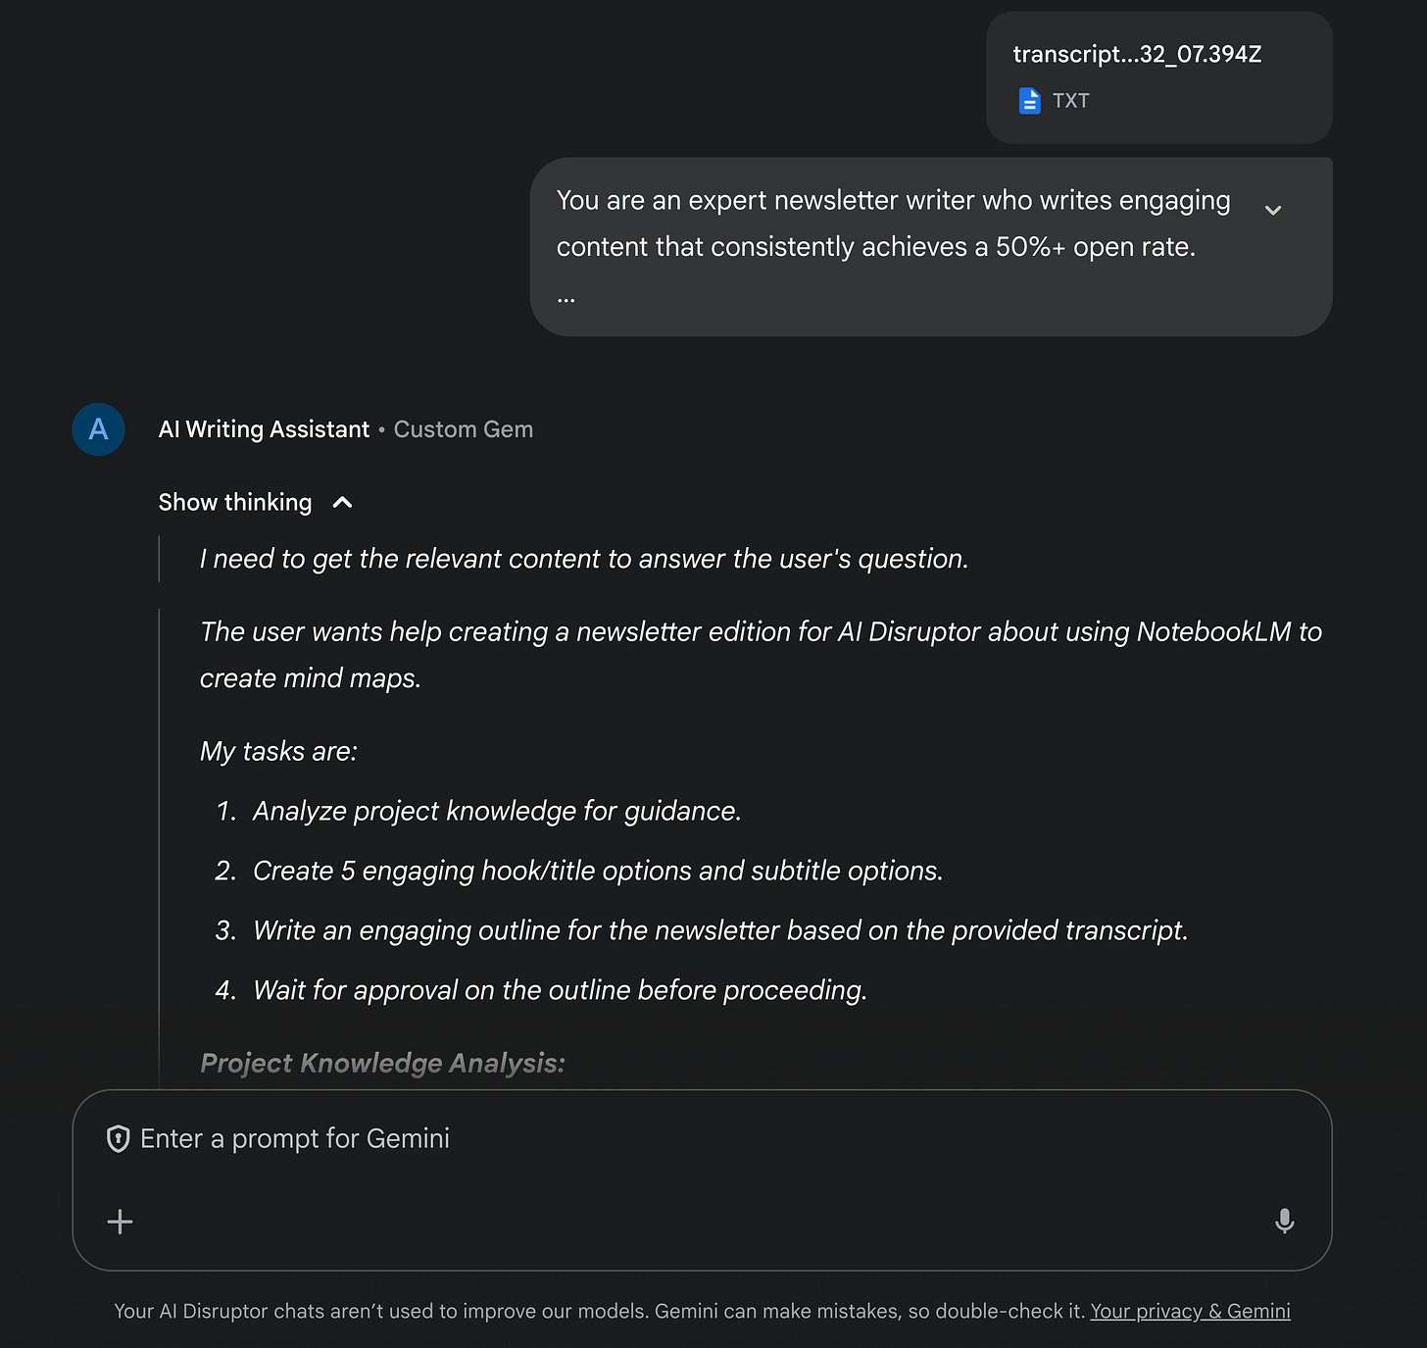

Unlock my Prompt Vault

Your Gemini writing assistant is now ready
And that's the core process! By creating a dedicated Gem, feeding it clear instructions, and grounding it in your own knowledge documents, you transform Google Gemini from a general AI into a specialized writing assistant tailored to you.
Recap of the steps:
- Create a New Gem in the Gem Manager.
- Write detailed Custom Instructions defining its role, purpose, and tone.
- Upload relevant Knowledge Documents (brand info, style examples, strategy docs).
- Interact within the Gem, giving it clear prompts for your writing tasks.
The real magic happens when the AI consistently applies your specific context and style, making your writing process faster and more efficient.
Don't be afraid to experiment, refine your instructions, swap out knowledge documents, and really make it your own personal AI ghostwriter.



Reco

